Tech Saksham

Case Study Report

**Data Analytics with Power BI**

“An Analysis of Unemployment in Republic of India”

”NAINA MOHAMED COLLEGE OF ARTS & SCIENCE”

|  |  |
| --- | --- |
| NM ID | NAME |
| 2E3166A70C9F2D49B964337A7980601B | K.YUVASRI |

TRAINED BY,

UMA MAHESHWARI.

ABSTRACT

Unemployment is a persistent problem in India, with significant social and economic consequences. This paper provides an overview of the current state of unemployment in India, including the latest unemployment rate and the factors contributing the Indian government has taken to address unemployment,such as skill development programs and the promotion of entrepreneurship and foreign investment. Despite these efforts, the challenge of creating adequate job opportunities for the growing population of India remains significant.This paper highlights the need for continued efforts to address unemployment in India and suggests potential solutions for improving the situation.

INDEX

|  |  |  |
| --- | --- | --- |
| SI.NO | Table of contents | Page No |
| 1 | Objectives of the study | 3 |
| 2 | Chapter-1 | 3 |
| 3 | Chapter-2 | 6 |
| 4 | Chapter-3 | 8 |
| 5 | Conclusion | 10 |
| 6 | Future Scope | 11 |
| 7 | References | 11 |

OBJECTIVES OF STUDY

• To study the present Condition of Unemployment in Rural andUrban area.

• To identify the Causes of Unemployment in India.

• To Examine the Government Programmers Unemployment

• Suggestions and Findings.

CHAPTER 1

INTRODUCTION

* 1. Problem Statement :

Unemployment persists as a significant socio-economic challenge in the Republic of India, posing serious implications for indivgraphics, and sectors. A comprehensive analysis of unemployment in India is crucial to understand its root causes, consequences, and potential solutions. The problem of unemployment in India is multifaceted and complex, characterized by structural, cyclical, and demographic factors. Rapid population growth, inadequate educational infrastructure, technological advancements, and insufficient job creation exacerbate the challenge, leading to a mismatch between labor supply and demand. Additionally, socio-economic disparities perpetuate unequal access to employment opportunities, exacerbating inequalities and hindering inclusive growth. Moreover, unemployment in India has far-reaching consequences beyond economic implications. It contributes to social exclusion, poverty, and disenchantment among the youth, fueling unrest and political instability.

* 1. Proposed Solution :

To effectively analyze unemployment in the Republic of India, a multifaceted approach combining quantitative research, qualitative insights, and policy recommendations is essential. The proposed solution outlines a structured methodology aimed at comprehensively understanding the dynamics of unemployment and formulating evidence based strategies to address it. By adopting this comprehensive approach, the proposed solution aims to generate actionable insights and policy recommendations to effectively tackle the issue of unemployment in the Republic of India, ultimately contributing to sustainable and inclusive development.

1.3 Feature:

* Integration of Emerging Technologies:

Understanding how these technologies affect job creation, skill requirements, and income distribution will be crucial for formulating effective policy responses.

* Focus on Reskilling and Upskilling:

Assessing the effectiveness of existing training programs and identifying areas for improvement will be essential. 

* Addressing Informal Employment:

A significant portion of India's workforce is engaged in the informal sector, where employment conditions are often precarious and income instability is common.

* Gender Disparities:

Gender disparities persist in India's labor market, with women often facing greater barriers to employment and advancement.

* Youth Unemployment:

India has a large and growing youth population, presenting both opportunities and challenges for the labor market.

* 1. Advantages :
* Informed Policy Decisions :

A thorough analysis provides policymakers with data-driven insights into the causes, trends, and dynamics of unemployment. This enables them to make informed decisions when designing and implementing policies aimed at reducing unemployment rates and promoting job creation.

* Targeted Interventions:

By identifying the specific demographic groups, regions, and sectors most affected by unemployment, an analysis can help tailor interventions and resources to where they are most needed. This targeted approach increases the effectiveness and efficiency of government programs and initiatives.

* Understanding Root Causes:

Unemployment is a complex issue influenced by various factors such as education, skills, labor market regulations, and economic conditions. An analysis helps uncover the root causes of unemployment, allowing policymakers to address underlying structural issues rather than merely treating symptoms.

* 1. Scope :

Examining national-level unemployment trends, rates, and patterns over time to understand the overall dynamics of unemployment in India. This includes analyzing data from official sources such as the National Sample Survey Organization (NSSO), the Labor Bureau, and the Census. Investigating disparities in unemployment rates across different states, rural-urban divides, and specific geographic regions within India. Understanding regional variations can help identify areas of concentrated unemployment and target interventions accordingly. Analyzing the impact of demographic factors such as age, gender, education level, and caste on unemployment rates. Investigating the mismatch between the skills possessed by the workforce and the skills demanded by employers.

CHAPTER 2

SERVICES AND TOOLS REQUIRED

2.1 Services Used:

* National Sample Survey Organization (NSSO):

Provides large scale survey data on various socio-economic aspects,including employment and unemployment. Census of India: Provides demographic data that can be used to analyze population characteristics and labor market dynamics.

* Statistical software packages such as SPSS, STATA, or R:

Used for data analysis, statistical modeling, and generating descriptive statistics. These tools enable researchers to analyze large datasets and identify patterns and trends in unemployment data.

* Qualitative data analysis software like NVivo or ATLAS:

Utilized for analyzing qualitative data from interviews,focus groups,or openended survey responses.These tools help researchers identify themes, patterns,and insights from qualitative data.

* Reserve Bank of India (RBI):

Provides economic data, reports, and research publications relevant to understanding macroeconomic trends and their impact on unemployment.

* Economic think tanks and research organizations:

Institutions such as the National Council of Applied Economic Research (NCAER) or the Centre for Monitoring Indian Economy (CMIE) produce research papers, reports, and data sets related to unemployment and labor market dynamics.

* Books and monographs:

Texts authored by experts in labor economics or Indian economy provide in-depth analysis and theoretical frameworks relevant to understanding unemployment in India.

2.2 Tools and Software used:

Tools:

• Power BI: The main tool for this project is Power BI, which will be used to create interactive dashboards for real-time data visualization.

• Power Query: This is a data connection technology that enables you to discover, connect, combine, and refine data across a wide variety of sources.

Software Requirements:

• Power BI Desktop:This is a Windows application that you can use to create reports and publish them to Powe BI.

• Power BI Service: This is an online SaaS (Software as a Service) service that you use to publish reports, create new dashboards, and share insights.

• Power BI Mobile: This is a mobile application that you can use to access your reports and dashboards on the go.

CHAPTER 3

PROJECT ARCHITECTURE

3.1 Architecture:

Here’s a high-level architecture for the project:

1.Primary Data Sources: Utilize official surveys such as the National Sample Survey (NSS), Labor Bureau reports, Census data, and other government sources for comprehensive data on unemployment.

2.Secondary Data Sources: Access data from international organizations like the International Labor Organization (ILO), World Bank, and academic research repositories for comparative analysis and additional insights.

3.Data Cleaning: Preprocess raw data to remove inconsistencies, errors, and missing values, ensuring data quality and reliability.

4.Data Integration: Integrate data from multiple sources into a unified dataset, harmonizing variables and formats for analysis.

5.Time-Series Analysis: Examine temporal trends in unemployment over different periods to identify cyclical patterns and long-term changes.

TABLE :

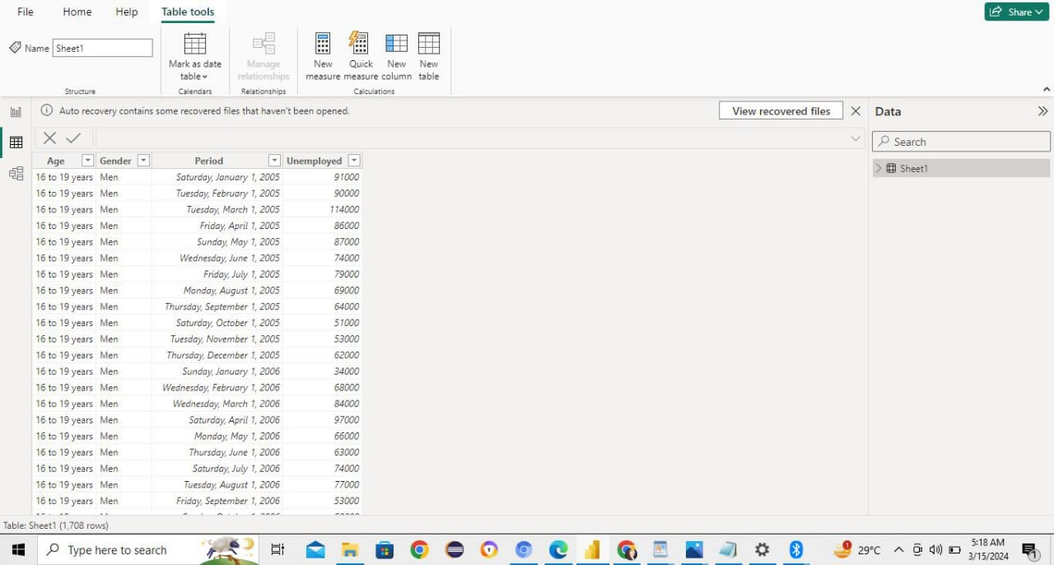

DASHBOARD :

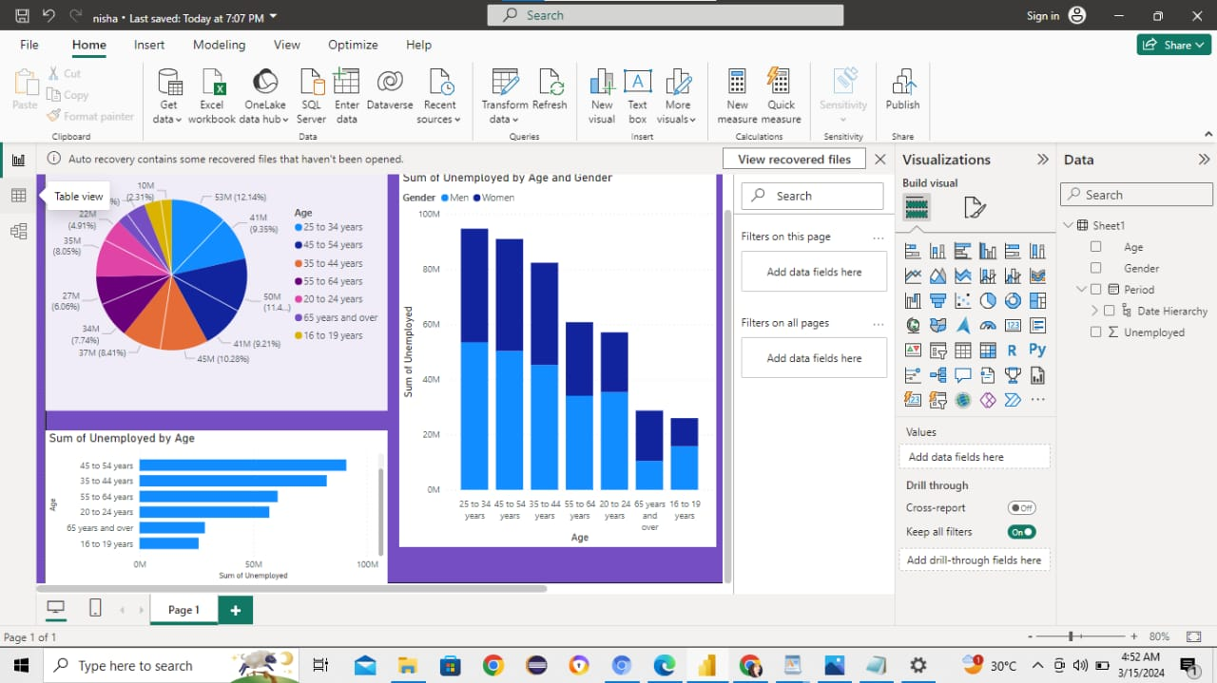

CONCLUSION

The analysis of unemployment in the Republic of India reveals a multifaceted and complex challenge with profound socio-economic implications. Throughout this study, we have delved into various dimensions of unemployment, exploring its causes, consequences, and potential solutions. Our analysis has highlighted the structural, cyclical, and demographic factors contributing to unemployment, including rapid population growth, technological advancements, and sectoral imbalances. We have also identified disparities in unemployment rates across regions, genders, and socio-economic strata, underscoring the need for targeted interventions to address inequality and promote inclusive growth.Furthermore, our examination of the socio-economic consequences of unemployment has revealed its far-reaching impact on poverty, social exclusion, and political instability. We have emphasized the importance of adopting a holistic approach to unemployment, addressing not only its economic dimensions but also its social and psychological implications.

FUTURE SCOPE

The future scope for an analysis of unemployment in the Republic of India is vast and presents numerous opportunities for further exploration and research.to track individuals' employment status over time can provide valuable insights into the dynamics of unemployment, including entry and exit patterns, duration of unemployment spells, and factors influencing transitions between employment and unemployment. Given the rapid advancements in technology and automation, future analyses could focus on the impact of technology on employment dynamics, including job displacement, skill requirements, and the emergence of new industries and occupations. With increasing awareness of environmental challenges, there is growing interest in the potential for green jobs and sustainable employment opportunities. Future analyses could examine the intersection of environmental sustainability and employment, including the potential for green growth strategies to create jobs while mitigating environmental degradation.

REFERENCES